An Academic Plan is a recommended sequence of courses based on a student’s academic record and degree requirements. It helps students find their path to academic completion.

Use this reference to create and edit an academic plan and to guide the student in making a saved schedule from the academic plan.

Contents:

Before You Begin 1
Create an Academic Plan 1
Help a Student Create a Saved Schedule from an Academic Plan 6

Before You Begin

Before you create an Academic Plan, be sure to review the student’s Academic Progress Report to view unsatisfied academic requirements as well as the courses needed to fulfill these requirements. You will need to add these requirements and courses to the academic plan. As you meet with the student, make sure the courses intended for the Academic Plan:
- Are available in the intended academic period
- Do not require prerequisite overrides
- Do not create scheduling conflicts

Create an Academic Plan

- Log into Workday. Type “Create Academic Plan” in the search bar. Press “Enter” or select from the auto-populated drop-down.

- In the Create Academic Plan window, type the student’s name in the Student field. Press “Enter”.

The Program of Study field will automatically populate with the primary program of study from the selected student’s record. Leave the Academic Plan Template field blank.

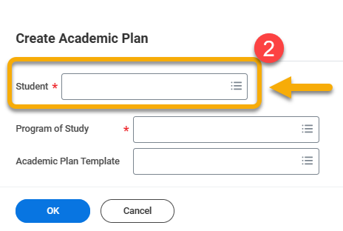

- Click “OK”.



- The Create Academic Plan page displays an auto-generated name for the academic plan in the Primary Plan Name field, tabs along the top for academic years, and a list of academic periods.

To begin creating the academic plan, select the academic year and period for which you want to create a plan

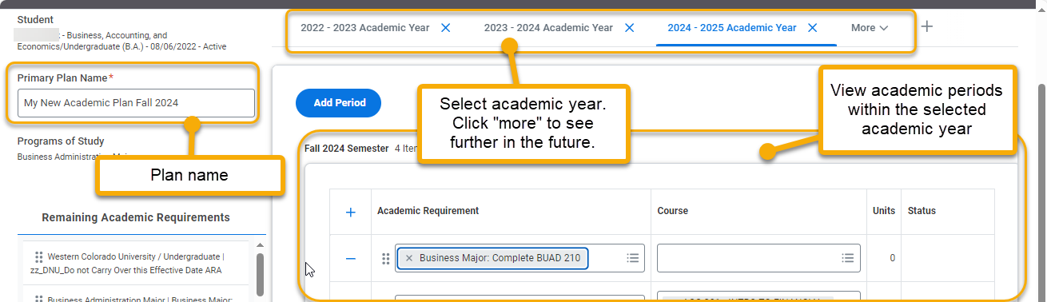

- Click the corresponding plus sign to add a new academic requirement.

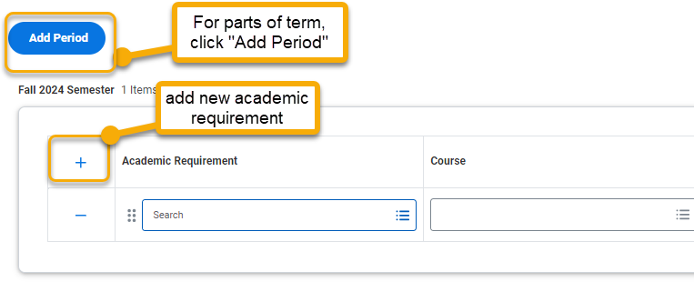

- Click the Academic Requirement field to reveal a drop-down menu of academic requirements attached to the student’s program of study. Click the Course field to select a course to fulfill the academic requirement.

TIP: Use the student’s Academic Progress Report to know which requirements are not satisfied.

- To add additional requirements, click the plus sign.

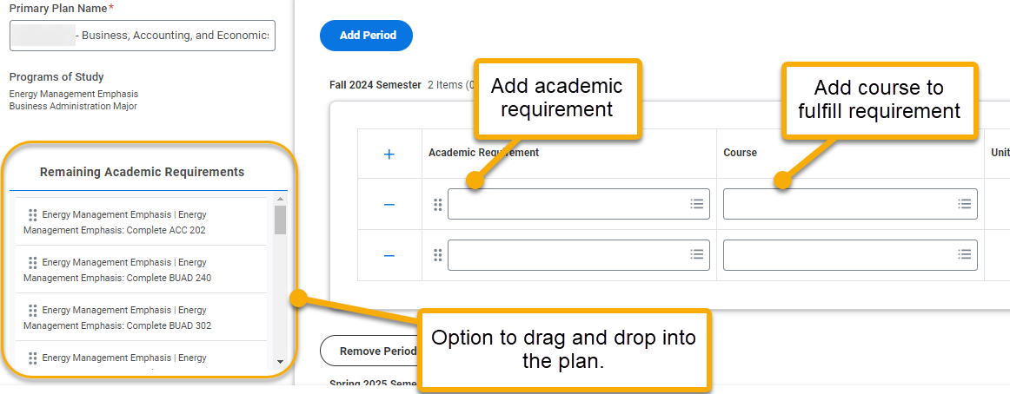

- When you want to add a course without an academic requirement, enter the course into the Course field.

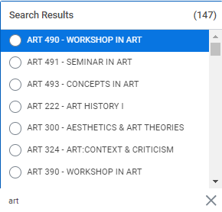

- When all academic requirements are added, click “OK”.



- At this point, the View Academic Plan page will appear and the student will have immediate access to the plan on their account.

- To create another academic plan for this student, click “Create Alternate Plan”. This will take you back to the Create Academic Plan page to create an alternative selection of courses.

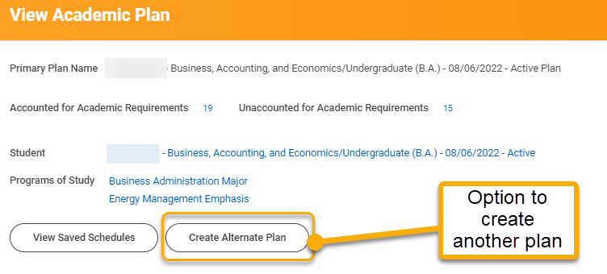

Help a Student Create a Saved Schedule from an Academic Plan

These steps outline how a student can view their academic plan and make a saved schedule based on this plan.

Create Saved Schedule from Academic Plan

- Log into Workday. From the Academics app, click “Create Saved Schedule from Plan”.

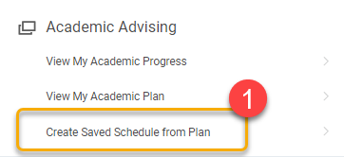

- From the pop-up window, click the Academic Plan field and select the desired plan name.

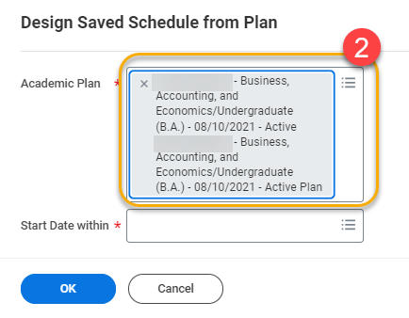

- In the Start Date within field, select the academic period corresponding to the academic plan from which you want to create a saved schedule.

In this example, the student wishes to create a saved schedule based on the Fall 2024 semester academic plan.

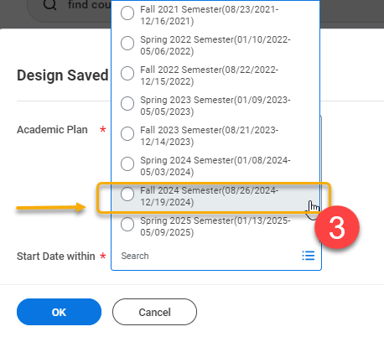

- Click “OK”.

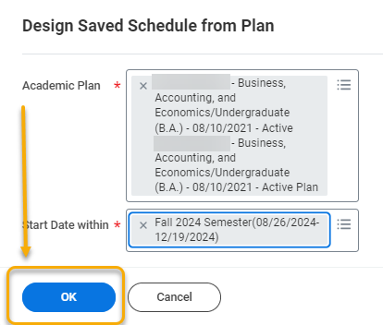

- On the Select Sections for Saved Schedule page, create a name for the new saved schedule.
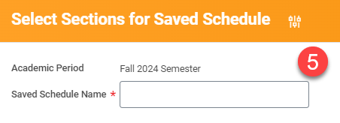

- Scroll down to view the classes in the academic plan on the left-side menu. Proceed to add or remove each course to your new saved schedule. To add, check the box next to the desired course section. To remove, click the trash can.

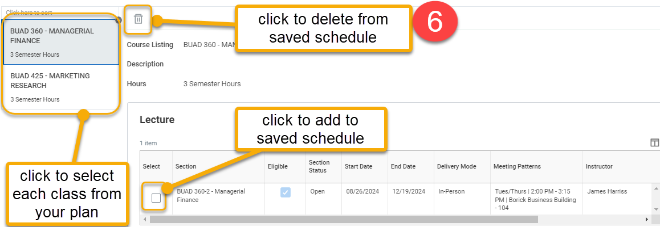

- When finished, click “OK”.

Note: At this point, you may receive errors or alerts. These are usually related to course section eligibility, waitlist, or schedule conflicts. Resolve these before proceeding.

- On the Add Course Section to Saved Schedule page, you have the option to see and print your new saved schedule in calendar view or to make additional edits. Do not click the “Add Course” button. This takes you to the entire university catalog.

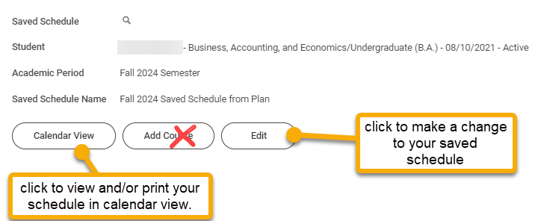

- Click “Done”.


- To view and/or edit this saved schedule on another day, click “View My Saved Schedules” on the Academics homepage.

